**Responsive Design 2**

**Exercise : To design webpage given in screenshots for all 3 devices.**

**Go for Mobile site first.**

**Question screenshots in next page :**

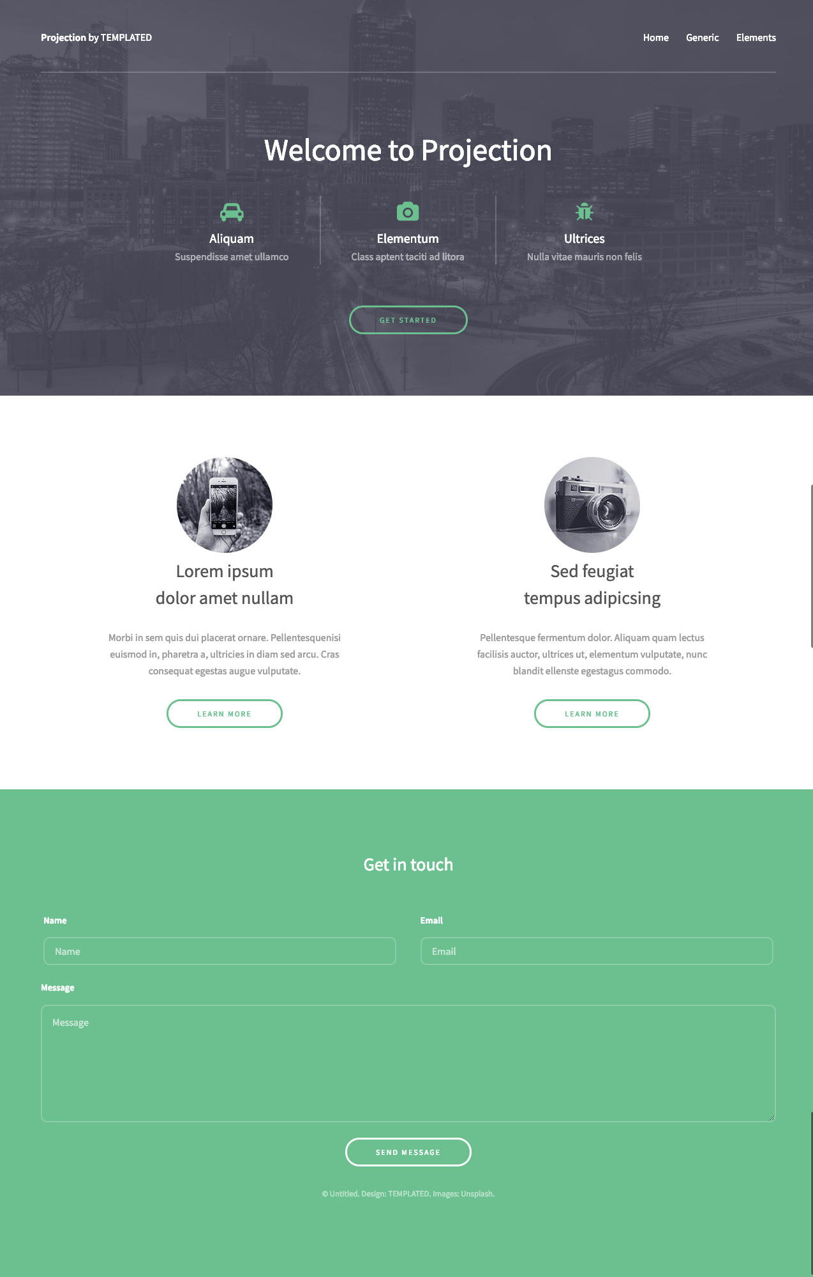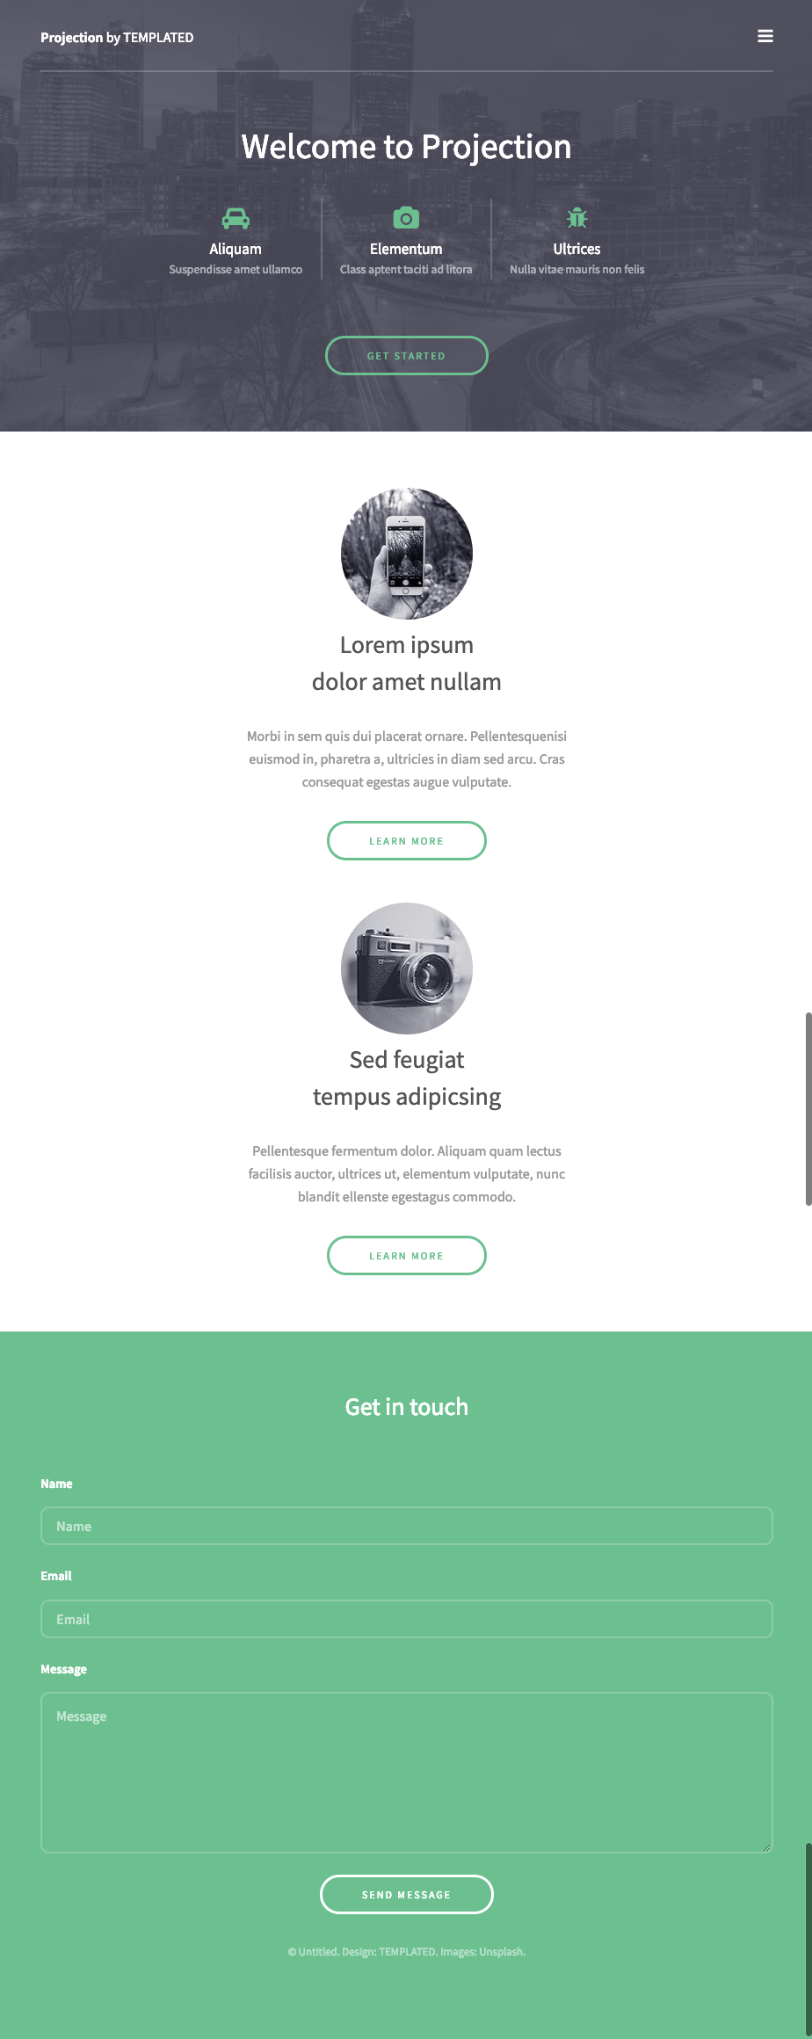

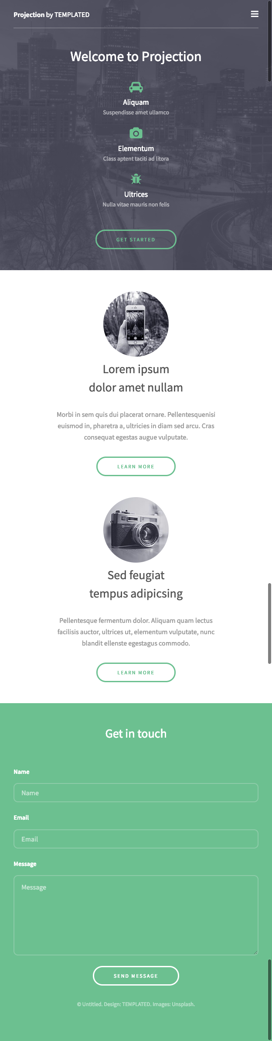

**Solution :** Please find index.html attached